Project 2

Ana Saavedra | Analiza Asuncion | Avantika Singh | Eric Wetzel | Sahar Alaei | Shilpa Nagendra

**Story –**

We are exploring the global popularity of VIDEO GAMES. We will be exploration the trends of the gaming industry for the last 40 years with popularity of consoles and specific games. With the data provided we can visualize the data with the different attributes we have learned in class with an interactive dashboard.

**Links –**

This is where we obtained our data.

<https://www.kaggle.com/gregorut/videogamesales>

* Rank - Ranking of overall sales
* Name - The games name
* Platform - Platform of the games release (i.e. PC,PS4, etc.)
* Year - Year of the game's release
* Genre - Genre of the game
* Publisher - Publisher of the game
* NA_Sales - Sales in North America (in millions)
* EU_Sales - Sales in Europe (in millions)
* JP_Sales - Sales in Japan (in millions)
* Other_Sales - Sales in the rest of the world (in millions)
* Global_Sales - Total worldwide sales.

<https://project-awesome.org/leomaurodesenv/game-datasets#dataset>

**Screenshots –**

The following is the snippet of the dataset we found to execute our project. 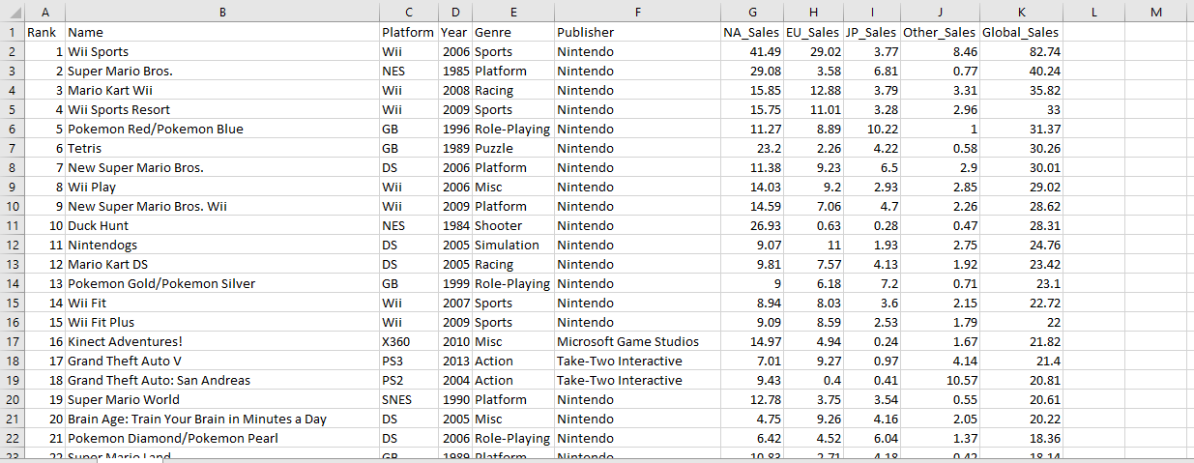

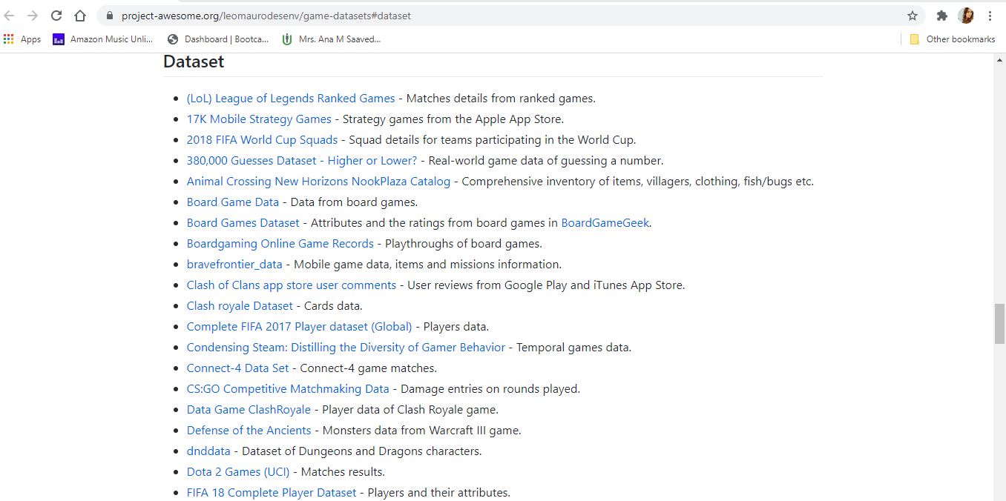

**Possible final design –**

The possible final design will be an interactive website with several pages with our visualizations. The visualizations will be interactive with the mapping being pulled from the dataset. Some of the visualizations will have user selection. With backend coding including Flask, JS, Plotly, D3, Geo-mapping and Leaflet.

* Leaflet choropleth map based on global sales
* Pie/donut chart based on game genres
* Line graph showing the trend of sales

**GitHub Repository –**

This is the link to our GitHub repository.

<https://github.com/Anabn357/Project-2>